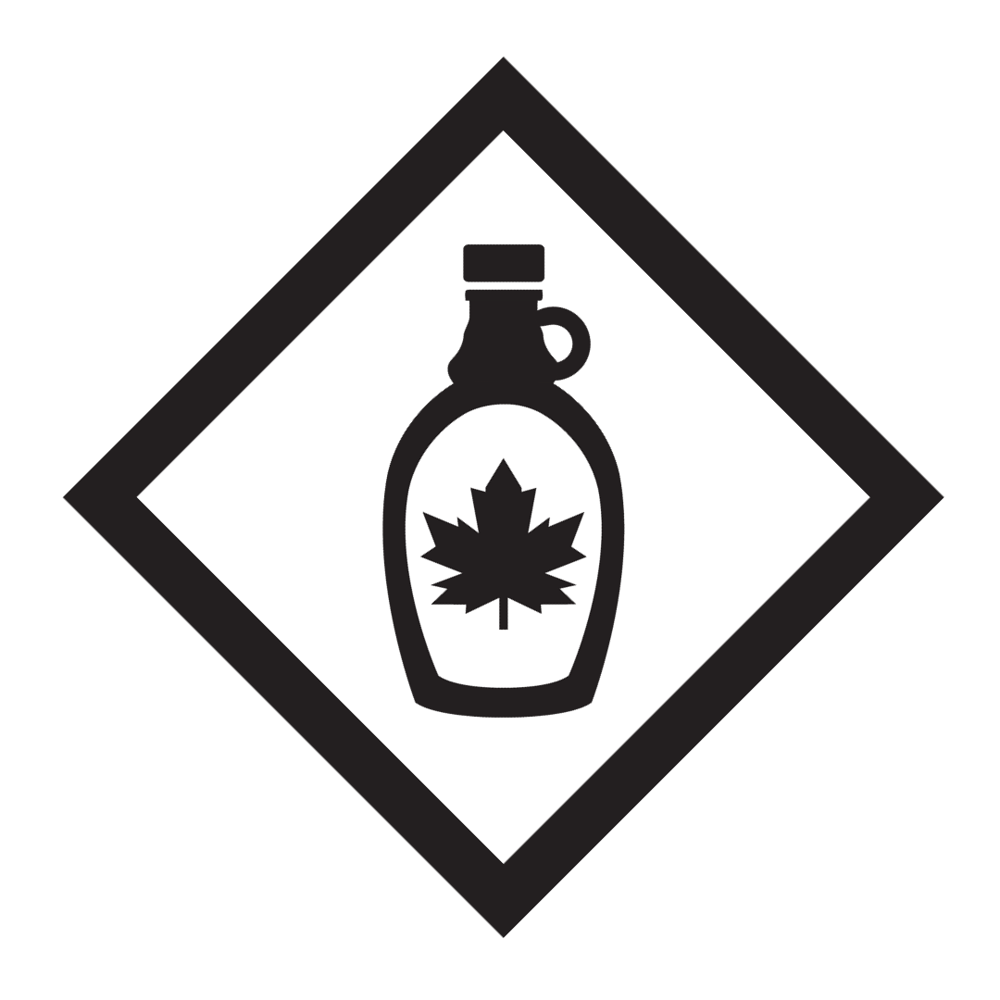
Maple Syrup Badge

“The trees of the Lord are full of sap, the cedars of Lebanon which he planted.”
-Psalm 104:16

PURPOSE: To discover the wonders of God’s creation by collecting and turning sap into sweet maple syrup.

LEARNING

1. Read the following verses and note which similarity is found in each scripture reading:

Exodus 15:24-26 |  |  | Proverbs 16:24
Psalm 19:7-11 |  |  | Proverbs 27:9
Psalm 119:103 |  |  | Ezekiel 3:2-4

Answer

2. Name at least six different essential tools / pieces of equipment used for making maple syrup and explain what each is used for.

Tool / Equipment Name | How Is it Used in the Making of Maple Syrup
3. List at least six different trees suitable for making syrup? Which is the best for making syrup and why?

4. What time of year is best for tapping trees and why?

5. How many litres of sap is needed to make one litre of maple syrup?

6. What is the typical boiling point of maple syrup? How does this compare to the boiling point of water?

APPLICATION

Complete the following activities.

1. With the help of an adult, identify and tap one or more maple trees and make your own maple syrup. If the trees are not yours be sure to get permission from the Owner.

2. Write a short essay of your experience collecting sap and making maple syrup.

3. Bring some samples to share with your fellow Kingdom Seekers and Counselors!

Counselor Signature: _________________________ Date: ___________________

